**THE SUPERIOR UNIVERSITY LAHORE**



**Term Project**

**M Usman Nawaz**

**BCSM-F20-329**

Program/Semester:

BSCS (5th) A

Subject: Technical & Business Writing

Instructor:

**Mam Qaisra Honey**

Department:CS

**The Impact of Mobile Technology On Social Behaviour & Human Relationships**

**INTRODUCTION & BACKGROUND**

Communication is an essential aspect of our society. Almost any work would become nearly impossible to achieve in this society without the use of communication. The early communication methods include a disorganized collection of making sounds, drawing in stones, imperial communication, pigeon post, etc. (Gascoigne, 2019). However, the human race reached a new milestone in communication after discovering the first practical telephone by Alexander Graham Bell in 1876 (Biography, 2018). After a few years, the idea of telephones got developed into mobile in 1940s by engineers of AT&T (Switch, 2020). Today, we have what is commonly known as smartphones.

However, these smartphones can do more than just communication. In this modern era, there is hardly any regular tasks that cannot be done by smartphones. Not only can we send messages and receive and make phone calls, but we can also record videos and capture photos, surf the internet, play video games and many more (Topper, 2019). Nevertheless, all these features come with a cost: its impact on social behaviour and human relationships. In this modern era, we have become so dependent on this mobile technology that we are gradually losing interest in traditional human interaction. Instant messages and phone calls have become so available that human face-to-face communication quality and quantity is deteriorating.

A survey on 120 senior students of Usman University revealed that mobile technology has dramatically reduced the face-to-face communication of the subjects with their close people. A significant reason behind this is that these students have become more reliant on mobile technology as it offers communication with many more diverse people with different backgrounds. The quantity of face-to-face communication also decreases because of the excess dependency on this mobile technology.

Another region-wise survey was done to observe the impact of mobile technology. The results showed that smartphones greatly deteriorate face-to-face communication quality due to its characteristic of occupying the users' minds, also known as absent presence. It was also observed that subjects who used smartphones were reluctant to spend in-person time with their friends. This absent presence can also impact the individual, such as lower productivity, increased procrastination, and other physical and psychological impacts.

**RESEARCH QUESTIONS**

Throughout my research paper, I will explore the impact mobile technology has on social behaviour and human relationships. I wanted to find out what is the effect of the advancement of mobile technology on an individual: whether they use it more or less after the advancement.

I would also like to find out whether mobile technology is related to any specific age group. This is because youngsters, especially those in their adolescent period, are more inclined towards the latest technological change. Also, absent presence is a common phenomenon in every person nowadays. Hence, I would also like to observe whether an individual is more active in their online social life than their actual in-person social life. Since online social life provides identity anonymity and a much more diverse choice of people from different backgrounds and races, people may be more interested in online social life.

I would also like to find out whether mobile technology affects an individual's emotional intelligence and whether there is any specific behavioural change. It is also believed that mobile technology helps a lot maintain human relationships, and I would like to find out how the human relationship gets helped by mobile technology. The answers of my questions finally got revealed through a combination of the conducted survey and some online research papers

**HYPOTHESIS**

I think that the impact of mobile technology on social behaviour and human relationships to be negative. Since almost every individual is too much dependent on mobile technology for its diverse features, the chances are that we may face some adverse effects

In some extreme cases, people also have Nomophobia unknowingly. Nomophobia is the fear that occurs during the absence of mobile phones, and this fear can adversely affect an individual's psychological conditions. Hence, people will be less prone to communicate with a person in the traditional method.

Due to technological advancement, messaging and calls can be made pretty quickly. People will tend to lose touch with each other since they will prefer this over the traditional method. As a result, both the quality and quantity of face-to-face conversation will deteriorate. Since mobile technology is rapidly evolving, and this will continue for the unforeseeable future, I expect that these adverse effects will become much more severe in the future.

**RESEARCH METHODOLOGY**

To fulfil my research goals, I used various sources like surveys, journals, online articles, research papers, and many more. All these helped me a lot to accomplish my research requirements.

For my primary research, I surveyed a representative sampling the people of Bangladesh and observed their responses to my questions. Since it is impossible to go outside due to the COVID-19 pandemic, I had to carry out an online survey created by Google Forms. My survey consists of 176 participants, most of whom were in the 11-30 age group and a few in the 40+ age group.

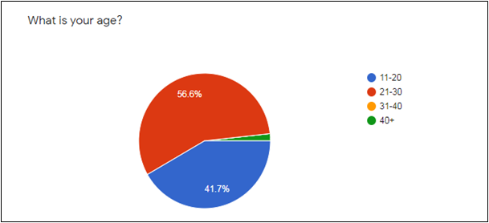

**Figure 1**

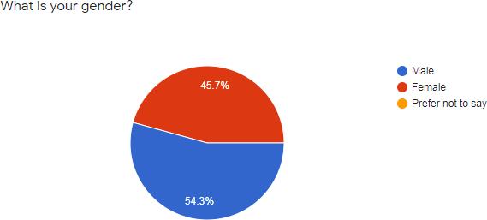

**Figure 2**

As shown in Figure 2 above, out of 176 participants, my survey consisted mainly of male participants (54.3%), and the rest percentage were female (45.7%).

For my secondary research, I used journals, online articles, various research papers, and many more, which helped me with my research paper. I also used the internet to cross-check my knowledge and check my secondary research materials' authenticity.

**DATA ANALYSIS**

The data collected from the online Google Form survey on a wide range of people is presented below:

At first, I asked the participants about their daily phone usage. 33.1% of the participants voted for 2-5 hours, and 27.4% voted for 5-8 hours. Also, a significant amount of participants (26.3%) voted for 8+ hours. A possible reason for this can be the COVID-19 pandemic; people started using phones for their works, but then again, 8+ hours is harmful for an individual.

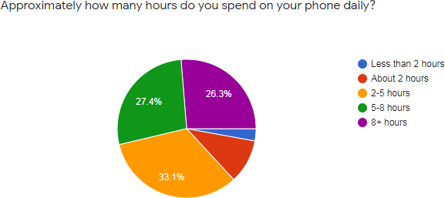

**Figure 3**

My second question to the participants was about their phone usage for academic/work purposes. The results in Figure 4 showed that 34.3% use them for less than 2 hours and 28% of people use for 2-5 hours, followed by 26.9% of people choosing about 2 hours range. A minor percentage of participants choose 5-8 hours and 8+ hours range. Comparing Figure 3 and Figure 4, we can see that the participants spend most of their time elsewhere and not on their academic/work purpose.

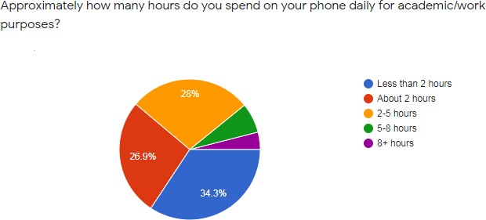

**Figure 4**

Next, I asked the participants about their social media usage using their phone, as shown in Figure 5 below.

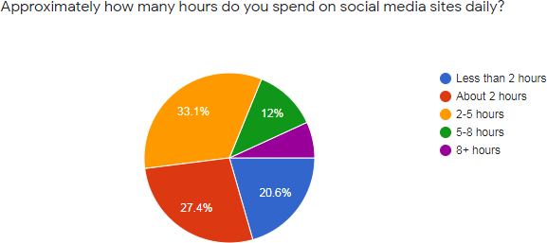

**Figure 5**

33.1% of participants opted for 2-5 hours range, and 12% also opted for 5-8 hours range, while 27.4% of people went for the about 2 hours range and 20.6% people for less than 2 hours range. So, 50% people use social media sites for almost 2 hours or less daily. The rest 50% uses from 2 hours to 8+ hours range. Thus, the individuals are using their phones more for

social media sites than their academic/work purpose, given the fact that 86.8% people use their phone from 2 to 8+ hours daily as shown in Figure 3.

The next question that I asked the participants was their total time spent with their family members (this includes normal talking and gossiping in person)

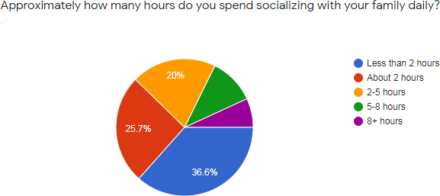

**Figure 6**

As shown in Figure 6, the highest number of people (36.6%) spend less than 2 hours with their families. 25.7% of people spend almost 2 hours with their family while 20% spend on the 2-5 hours range. Only 17.8% of people spend 5 to 8+ hours with their families. If we compare Figure 6 with the previous results, it will be quite clear that individuals are giving more importance to their online social life compared to their real social life.

I also wanted to explore the impact of mobile technology development on the screen time of an individual. So, I asked my participants whether they use smartphones more than the previous handheld phones. The results are shown in Figure 7 below

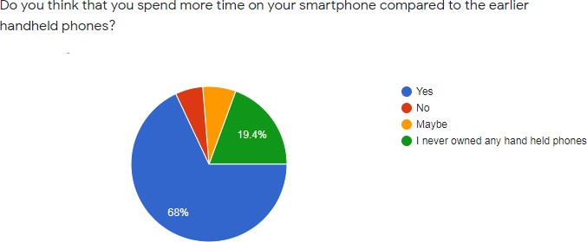

**Figure 7**

A further behavioural impact investigation showed that 50% feel comfortable chatting while the other 50% prefer in-person conversation. The reasons for the 50% Yes candidates are shown in Figure 8:

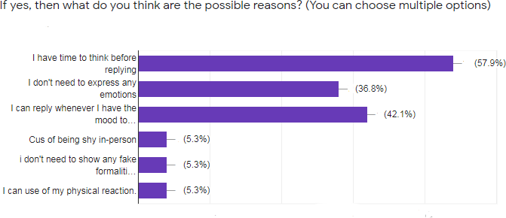

The majority stated a reason as thinking time before reply (57.9%) since, in everyday conversation, one has to reply almost instantly. Then another 42.1% stated that they could reply whenever they want to, and 36.8% stated that they don'1 have to show any emotions. This is the

result of the extreme dependency of people on mobile phones. They have become so much attached to this technology that face-to-face communication seems problematic, and their emotional intelligence has deteriorated.

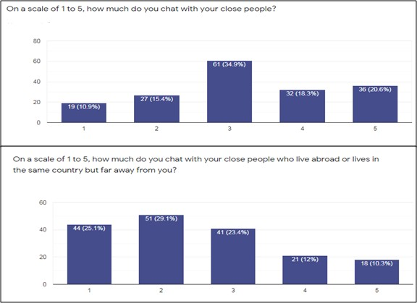

**Figure 9**

**SUMMARY OF RESEARCH FINDINGS**

Thus, the impact of mobile technology on social behaviour and human relationships to be negative. The dependency on mobile technology is too much, and thus the users face many adverse effects. The quantity of face-to-face communication decreases due to the increased dependency on communication methods that don't require any means of interaction and emotions. The amount of unnecessary mobile phone usage hours is also very high. The quality of face-to-face communication has also decreased since the time spent with family is also very short compared to online social life. Symptoms of Nomophobia are also being observed in an individual.

The advancement of mobile technology will be continuing for the unforeseeable future. Hence, it can be expected that the problems will become much more severe in the future. Also, mobile technology has an insignificant contribution to the connectivity maintenance of human relationships when it comes to human relationships. Overall, mobile technology does more harm than good to these two aspects of human lives.

**RECOMMENDATIONS AND CONCLUSION**

From my research, I have concluded that mobile technology negatively impacts social behaviour and human relationships. The impact is usually found on the adolescent to adult age range, and the advancement of mobile technology has caused a huge increase in its usage. As a result, people seem to give more importance to their online social life than real social life. Mobile phone users also have Nomophobia without having the slightest idea about it, and their emotional intelligence is also greatly deteriorated. In addition to all these, people seem to think that mobile phones help to maintain their relationships. In contrast, it can be seen that mobile phones may help to keep close-range connectivity but does little or no help for long-distance relationships.

A possible recommendation is to reduce the extent of these adverse effects is to make a daily routine. The routine will consist of allocated hours for different activities, and the activity with the most urgency gets the priority of the number of hours. A much more comprehensive recommendation could have been concluded if an extensive scale survey, along with some interviews, could be done. Moreover, I think that this problem will grow exponentially in the future. Hence, people should be careful when depending on mobile technology and should also keep the mobile phone activity in check.